**Yr 10 Motion Equations and Graphs Revision**

1. In physics, what are the standard units for time and distance?
2. Why do physicists use standard units?
3. Convert the following into standard units:
   1. 2.5 km b) 7 minutes c) 340 cm d) 2.5 minutes
4. Explain, with examples, the difference between distance and displacement.
5. Describe a situation where an object travels a distance, but has a displacement of zero.
6. For each of the diagrams, state the distance and the displacement of the object.

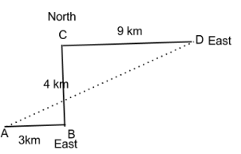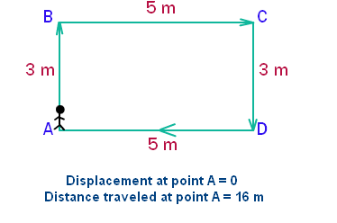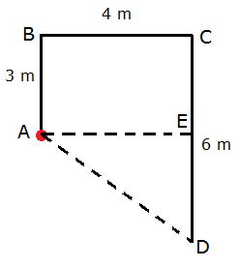

1. Explain the difference between scalar and vector quantities. Give an example of each.
2. Look at the displacement-time graph below.

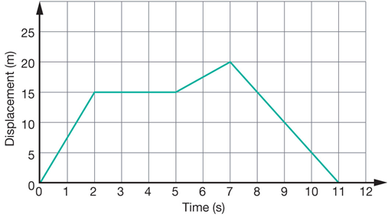

* 1. Describe the motion of the object in the graph.
  2. What distance has the object travelled in total?
  3. What is the object’s final displacement?

1. **On a sheet of graph paper**, draw displacement-time graphs for the following situations.
   1. It takes you 3 minutes to walk 200 m to your friend’s house. You wait for them for 1 minute before you walk to school together. It takes you 5 minutes to walk 350 m to the school gate.
   2. It takes a worker 1 hour to cycle 20 km from home to their job. They spend 5 hours at work, before taking 1.5 hours to cycle home.
   3. It takes a bird 4 seconds to fly to a birdbath 40 m away from its nest. It stops to drink for 2 seconds. It flies back towards its nest at the same speed, but when it is halfway back, pauses for 1 second to collect a twig.
2. Describe two ways speed and velocity are different.
3. A car travels 117 km in an hour and a half. What is the average speed of the car in km/h?
4. A train is travelling at 15 m/s north. What is its displacement after 10 minutes?
5. A man riding in a shopping trolley travels 400 m in a minute. How fast is he travelling in m/s?

1. A bus is travelling at 50 km/h. How long does it take for the bus to travel 80 km?
2. Barry the human cannonball is fired from a cannon. If the cannon shoots him out at 12.8 m/s and he is in the air for 8.5 s, how far away should the safety net be?
3. What is acceleration and what units are used to show acceleration?
4. What does a negative acceleration tell you about the object?
5. A cyclist accelerates from 5 m/s to 10 m/s in a time of 2 s. What is their acceleration?
6. A car accelerates from rest (0 m/s) to 20 m/s. If the car accelerates at 5 m/s2, how long does it take a car to change velocity?
7. An object decelerates at – 3 m/s2 for a time of 3 seconds. What is its change in velocity?
8. If the object in the previous question started at a velocity of 18 m/s, what is its final velocity?
9. What does a velocity-time graph show?
10. How do you use a velocity-time graph to find displacement?
11. Describe the changes in motion for the objects in the graphs below. (Constant velocity, accelerating, decelerating etc.)

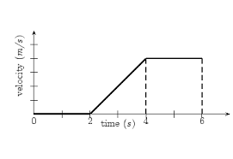

2

1

3

4

5

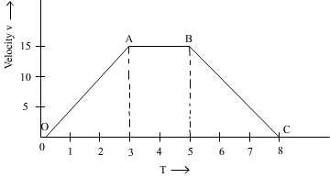

1. Find the displacement of the objects in the velocity-time graphs.